

**Bahir Dar University**

**Bahir Dar Institute of Technology**

**Faculty of Computing**

**Requirement Analysis Document**

**For**

**Industrial project on Students’ Union Web Based Voting System**

Submitted to the faculty of computing in partial fulfillment of the requirement for the

Degree of Bachelor of Science in Software Engineering

Group members ID Number

1. Sosina Molla 1011652
2. Tigist Tefera 1010774
3. Wengelawit Alelign 1010925

Advisor: Mr. Mebratu B.[2014]

Bahir Dar University, Bahir Dar Institute of Technology

# Declaration

The Project is our own and has not been presented for a degree in any other university and all the sources of material used for project have been duly acknowledge.

……………Sosina Molla………………. …………………………………

Name Signature

………………Tigist Tefera……………. …………………………………

Name Signature

………………Wengelawit Alelign……… …………………………………

Name Signature

Faculty: Computing

Program: Software Engineering

Project Title: Web Based Student Union Voting System

This is to certify that I have read this project and that in my supervision and the student’s performance, it is fully adequate, in scope and quality, as a project for the degree of Bachelor of Science.

………Mr. Mebratu M. ……………........... ………………………………

Name of Advisor Signature

Examining committee members Signature Date

1. _________________ __________ _________
2. _________________ ___________________
3. _________________ __________ _________

It is approved that this project has been written in compliance with in formatting rules laid down by the faculty.

**Roles and Responsibilities of the Group Members**

|  |  |  |  |
| --- | --- | --- | --- |
| List of task | List of members | | |
| Sosina | Tigist | Wengelawit |
| Requirement gathering |  |  |  |
| Analysis phase |  |  |  |
| Design phase |  |  |  |

# Acknowledgment

First, we would like to acknowledge “The Almighty of GOD”, the supreme authority of the universe that help us in everything ways that made us safe.

Following this, we want to express our gratitude mainly to our Advisor Mr. Mebratu M., for his technical guidance, constant encouragement and constructive advice, despite the busy schedule.

Finally, our sincere gratitude goes to all the people who providing us all the necessary information we required regarding the system. We also want to thank those that intentionally or unintentionally helped us in facing our obstacles and helped us to perform the progress.

# List of Acronyms

* **UML**: - Unified Modeling Language
* **WAMP:**- Windows, Apache server, My-SQL, PHP
* **CPU:**-Central Processing Unit.
* **CSS**: - Cascade Style Sheet
* **CGPA:-** Cumulative Grade Point Average
* **DB:**- Data Base
* **BDU:** Bahir Dar University
* **GB:**- Giga Byte
* **GHZ:**-Giga Hertz
* **HTML**:-Hyper Text Markup Language
* **MB:**-Mega Byte
* **MS office**: - Microsoft Office
* **OVS: -** Online Voting System
* **PHP**:- Hypertext Preprocessor
* **RAM:**-Random Access Memory.
* **SQL**:-Structural Query Language
* **UI:**- User Interface
* **UN**:- User Name
* **PW**: Password
* **ID:**- Identification Card
* **BR:**- Business Rule
* **MySQL:-** My Structured Query Language

# List of Tables

Table 1 : Schedule 7

Table 2 : Use case description for register 15

Table 3 : Use case description for create account 16

Table 4 : Use case description for edit account 16

Table 5 : Use Case description for Election Campaign 17

Table 6 : Use Case description for Approval of Vote Committees 18

Table 7: Use Case description for Approval of Candidates 19

Table 8 : Use Case description for Voting 20

Table 9: Use Case Description for View 21

Table 10 : Use Case Description for Creating Notice 21

Table 11 : Use Case Description for Cancel candidate 22

Table 12 : Use case description for cancel vote 23

Table 13 : Use Case Description for Generating Report 24

Table 14: Use case description for change password 25

Table 16 : Hardware tools 51

Table 17 : Software Tool 52

Table 18 : CRC diagram for Candidate 53

Table 19 : CRC diagram for Voter 53

Table 20 : CRC diagram for Vote Committee 54

Table 21 : CRC diagram for campaign 54

Table 22 : CRC diagram for result 54

Table 23 : Access Control and Security 61

**Table of Figures**

Figure 1 : Use case diagram 26

Figure 2 : User interface prototype 27

Figure 3 : State diagram for voting 28

Figure 4 : State chart for create account 29

Figure 5 : State chart for create notice 30

Figure 6 : Activity diagram of login 31

Figure 7 : Activity diagram of voting 32

Figure 8 : Activity Diagram for Creating Notice 33

Figure 9 : Activity Diagram for Election campaign 34

Figure 10 : Activity Diagram for Registration 35

Figure 11 : Activity Diagram for Report Generation 36

Figure 12 : Activity Diagram for View 37

Figure 13 : Sequence diagram of login 38

Figure 14 : Sequence Diagram for Election campaign 39

Figure 15 : Sequence Diagram for Cancellation 40

Figure 16 : Sequence Diagram for Creating Notice 41

Figure 17 : Sequence Diagram for Voting 42

Figure 18 : Sequence Diagram for Registration 43

Figure 19 : Sequence Diagram for Report generating 44

Figure 20 : Sequence Diagram for View 45

Figure 21 : Analysis class models 46

Figure 22 : System Architecture 56

Figure 23 : Component modeling 57

Figure 24 : Deployment modeling 58

Figure 25 : Detail class model 59

Figure 26 : Persistent mode 60

Figure 27 : Login page 62

Figure 28 : Candidates registration page 63

Figure 29 : Election campaign form 64

Table of Contents

Declaration II

Acknowledgment IV

List of Acronyms V

List of Tables VI

ABSTRACT X

CHAPTER ONE 1

1. INTRODUCTION 1

1.2 Problem of the Existing System 3

1.3 Objectives of the project 4

1.3.1 General objective of the system 4

1.3.2 Specific objectives 4

1.4 Methodology 4

1.4.1 Data Collection Method 4

1.4.2 Design Methodology 5

1.4.3 Implementation Methodology 5

1.6 Significance of the project 8

1.6.1 Target Beneficiaries of the System 8

1.9 Organization of The project 10

CHAPTER TWO 11

System Feature 11

2.1 Over View of the Existing System 11

2.2 Over View of the Proposed System 11

2.3 Requirement analysis 12

2.3.1 Functional requirements 12

2.3.2 Use Case Modeling 14

2.3.2.1 Specification of Actors 14

2.3.2.2 System use case diagram 26

2.3.3 Business Rule 26

2.3.6 Activity Diagram 30

2.3.7. Sequence Diagram 38

2.3.9 Logical Model 47

2.5 System requirements 51

2.5.1 Hardware requirements 51

2.5.2 Software requirements 52

2.6 Key abstraction with CRC Analysis 52

CHAPTER THREE 56

3. System Design 56

3.1 Architectural Design 56

3.1.1 Component Modeling 57

3.2 Detail Design 59

3.2.1 Design Class Model 59

3.2.2 Persistent Model 60

3.3 Access Control and Security 61

3.4 User Interface Prototyping 62

Reference……………………………………………………………………..…………………66

Appendixes 66

**ABSTRACT**

This web based voting system is mainly designed for the Bahir Dar University students’ union. The system is easy, fast and efficient. And it can be performed simply with a little knowledge of computer.

Web based voting system helps its users (students) to vote their own representatives. Generally these and other detailed features of this system make it so interesting to be used by the Students’ union office.

This project emphasizes on the manual system. After studying this manual system by using different types of methodologies we have developed this project that simplifies the coordinating and advising system by automating some of the activities that are done manually. Generally this system has major mechanisms to submit vote online, enable students and candidates to get fair election and other uses.

This project also talks about the advantages of the web based voting system that motivates different institutes and organizations to develop the web based voting system applications. It also expresses the key issues that need to be considered during the development of this project. It will show the design of the project and the information of the tools and techniques that were used to documented the project and implementation tools of this system. And we try to put sample UI and sample algorithm design of the project.

# CHAPTER ONE

# 1. INTRODUCTION

## Information technology plays a big role one’s country society. With the introduction of computers, the business world was changed forever. Using computers and software, businesses use information technology to ensure that their departments run smoothly. Web application is one category of information technology in which applications and information are stored on servers and users can access that information using web browsers.

## Web based voting system is a web application that allows voter can vote their representative easily in voting systems. In web based student union voting system election can be conducted in free and fair manner in every twoyears in secret ballots. The president, the vice president and the general secretary come to power through direct election in a secret ballot every two year per their vote they secured. The person with the highest vote shall become the president, in addition to these chief executives, the union has executive committees. The aim of our project is to develop an interactive, electronic, voting system for Bahir Dar student union members’ election with which students can vote using a web browser. It automates the existing manual activities like voter registration, candidate & election process voting and vote counting. The project is expected to help students as well as the university at large in overcoming the existing voting problems such as time consuming voting process, extravagant resource oriented election, geographical limited voting, and undocumented and unstructured information capture. The system makes not only the voting process easy but also assist students by providing them with information associated with the student union. The system is capable of improving the user effort and time required and reduces the resource expenditure of the university.

**1.1Background of the Organization**

Bahir Dar University was established by merging two former higher education institutions; namely the Bahir Dar Polytechnic and Bahir Dar Teachers’ College. The Bahir Dar Polytechnic Institute, which has transformed itself into Technology and Textile institutes, was established in 1963 under the technical cooperation between the Government of the USSR and the Imperial Government of Ethiopia.

The Bahir Dar Teachers’ College, by then known as the Academy of Pedagogy, was established in 1972 by the tripartite agreement of the Imperial Government of Ethiopia, UNESCO and UNDP and started actual work in the following year under the auspices of the Ministry of Education and Fine Arts.

* + 1. **Mission**

The mission of Bahir Dar University is to contribute substantially to the nation and beyond through high quality education, research and community services.

* + 1. **Vision**

The vision of Bahir Dar University is to become one of the ten premier research universities in Africa by 2025.

### Problem of the Existing System

Existing system has a number of problems in the working procedure for university and students. At present Bahir Dar University manual system to deal with the voting system. The existing student union members voting system has the following problems:

Advertisement problem, extravagancy of resource, security (cheating) problem, an error related problem and lack of fast service.

**Advertisement Problem:** The candidates do not advertise themselves before the vote day effectively. So many students had no clue about the candidate profile before the Election Day. Many students do not know when and where the election is performed. This means the students were not informed timely.

**Extravagancy of Resource:** During the election time the students are physically present and contact or meet in the election hall. In this point of view there is time consumption and human power consumption.

In case of *time consumption*, the students spend very much time on the Election Day, rather to do other activity or task of academic relatives things. This can be happen because of all students cannot be at planned and specific time.

Regard to *human power consumption* more students are needed to operate the election process and during counting score of the candidate get from election. Other resource like, paper, pen, space to store all the collecting data are consumed very at high level.

**Security (cheating) Problem:** During the counting of vote result there was a cheating regarding to the score of the candidate vote. The vote committee is also seems or totally do their task with clan and religion based. At the pointing of the candidates, they give a chance to students what they know.

**Error related Problem:** At the time of counting the result of the candidates vote there occurs an error by mismatching the vote and other reason.

**Lack of Fast Service:** At the election time there is not fast service delivered to the students. So they are too late to announce who win the election.

## 1.3 Objectives of the project

### 1.3.1 General objective of the system

The general objective of our project is to make web based voting system to the current manual voting system for Bahir Dar University students’ union.

### 1.3.2 Specific objectives

The specific objectives of this project are:

* To register the candidates, voters and voting committee over the internet connection.
* Design user friendly interface.
* Implementing web based voting system.
* Gathering requirements.
* Selecting appropriate development tools for the system.
* Coding and testing.
* Supersede the current system voting of Bahir Dar University Students’ union.
* Reduce wastage of resource like time, human power, storage space.
* Authenticating Students’ union voting system.
* Organize, manipulate, record, store and retrieve data in automated way.

# 1.4 Methodology

### **1.4.1 Data Collection Method**

We used the following methods to gather information about the current system and alternate ways to develop the new system.

* **Interview**: - To collect information from the president of the student council and executive members of the union.
* **Observation: -** As we are the member of this university we know how to perform the election activity and the office structure. So that, we observe and trying to solve the problems what we have seen.
* **Document analysis**: - we refer books, documents and other reading materials from Internet.

## 1.4.2 Design Methodology

To design the system, the project team has chosen Object Oriented Modeling techniques and unified modeling language tools.

Tools we use in this design method are:-

* **Object Oriented Analysis (OOA)**

In this phase the functional requirements are separated from the non-functional one and the conceptual class diagram is designed. During this phase the team uses to model the function of the system (use case modeling), find and identify the business objects, organize the objects and identify the relationship between them and finally model the behavior of the objects in detail.

* **Object Oriented Design (OOD)**

During this phase our team uses Lucid Chart and Edraw max software to design the use case model, sequence diagram, activity diagrams, deployment diagram and system class diagrams.

* **Object oriented implementation (OOI)**

In this phase we will use PHP platform, html, CSS, XAMPP and MYSQL.

## 1.4.3 Implementation Methodology

While developing the project we use the following hardware and software tools:-

**1.4.3.1 Software tools/requirements**

* **HTML:**for designing the interface, for the formatting of the system.
* **PHP:** We use for data manipulation, retrieving and storage of data into database.
* **MySQL:** for back end.
* **CSS:**for the formatting of the system. That is it defines the style of a website’s content.
* **Java script:** We use java script for the doing the validation of all text fields.
* **Implementing/Texteditor:** - notepad, notepad++.
* **WAMP/XAMPP server**: manage servers setting.
* **Operating System**- Windows 10.
* **Browsers:** Internet explorer, Firefox and Chrome.
* **Lucid Chart, DB schema and Edraw Max**: used to draw different UML those are necessary to structure the system. E.g. Activity Diagram, Class Diagram, Sequence Diagram, persistent diagram and Use case Diagram.

**1.4.3.2 Hard ware requirement**

* **USB:** - 16 GB.
* **RAM: -**8.00 GB.
* **Personal computer**: - to write documentation and implementation.
* **CPU**: - 64 bit core and 1.60 GHZ or higher that is responsible for data processing operation.

**1.5 Feasibility study**

The feasibility study aims to provide answers to a number of issues such as: - Is it easy to operate? Is the system easier for maintenance?

**1.5.1 Economic feasibility**

The current system used by the student union election result in enormous expenditure on paper, pen, time and other costs due to improper mechanism to deal with the customer information. The project resolves these additional requirements by using a computerized system. The new system is economically feasible. Economic feasibility can be seen in two ways:

* **Tangible benefits**

The system has Tangible benefits such as:

* Cost Reduction
* Error Reduction
* Increase Speed of activity
* **Intangible benefits**

The system has intangible benefits such as Reduce Resource Consumption, increase Security, reliability and trust.

**1.5.2 Schedule feasibility**

The system after development may give efficient and effective services in short period of time. And also the tasks may be scheduled for effective use of the system. The project will be finish at the schedule time. So the project is Schedule feasible.

*Table 1 : schedule*

|  |  |  |  |  |
| --- | --- | --- | --- | --- |
| Activity | April 15-20 | April 21-May 15 | May 16- June 1 | Responsible |
| Requirement gathering |  |  |  | All member |
| Requirement analysis |  |  |  | All member |
| System design |  |  |  | All member |

**1.5.3 Technical feasibility**

Web based student union voting system is technically feasible. In order to ensure whether the system is technically feasible or not, the system should specify the following cases:

* The software currently possess the necessary technology: Because it achieves the required goal, as much as possible we tried to encounter all hardware and software requirements and also the technology is easily available and deployed everywhere.
* The new system posses’ necessarily technical experts: In this project the team uses languages such as HTML, PHP, java script and CSS to develop the new system. Example to control double voting using voting states when the voter vote on candidate then the vote states can be voted. All these are the technology side and once the module is developed it can be easily held by non-technical person, so it doesn’t require any technical expertise.

## 1.6 Significance of the project

The significance of the project means the important role of the project to all the societies, the users and to the concerned bodies.

* It will enable the administrator to update, delete and edit information about the voter, vote committee and candidate simpler.
* Error of counting of votes will not occur, because the system assures that counting is done automatically so that there are no voting frauds at all.
* Increases accuracy and availability and quality of the voting process and number of voters as individual will find it easier and more convenient to vote.
* It will reduce the wastage of resources.
* It will eliminate and reduce technical error. When an error occurs during election, the vote committees arrange and correct.
* It will eliminate voting repetition by making the account of the voter inactive, once he/she gives vote.
* It increases the trusts of the voters’.
* It is not determined by geographical barrier. The students will get all election information on time and register, elect where they were been.
* It automates all election related data evolved in election time.

## 1.6.1 Target Beneficiaries of the System

When this project is finished the following compound’s society as well as the university get some benefit.

* **Student:** They will get any information without geographical barriers and elect everywhere that internet connection is available. And also they will reduce wastage of time during the time election.
* **Vote committee:** There is no any tedious task they will do. Only sit observe and control the vote process.
* **Students’ Union:** The newly proposed system will reduced the extravagancy of resources like time, human labor force and some materials.
* **Candidates:** The candidates get fair election according their advertisement of what they use.
* **University:** Since it is a time of globalization, our project encourages communication with electronic devices so that the community of the university will get rid of manual works.
* **Project developer:** The developers, which participating in this project will provide to know how to developed one system or model and getting a knowledge or wisdom to designing, modeling and implementing another new system.

**1.7 Limitation of the project**

Some of the limitation of this project is:-

* The system uses only English language.
* Does not work without internet connection.
* Not used for blind users.
* The system does not work for users who have button type phone.

**1.8 Scope of the project**

The scope of the project refers to the area, where the ongoing system is applied and how much it is powerful to solve the problem. The following are the scope of web based student union voting system for Bahir Dar University.

* The system shall allow creating new account for users.
* The system shall allow login only for authorized and authenticated users.
* The system shall validate and authenticate the users’ username and password.
* The system shall allow register voters (students in our case).
* Register the candidates according to the fulfillment of the policies, rules and regulation listed below.
  + - The candidates should not be from the graduation class students.
    - Free from any addiction and discipline case.
    - The CGPA must above or equals with 3.00.
* Approve the candidates according to rules, regulation and the time they registered.
* It allows the voters to elect the candidates.
* Calculate total number of votes for each candidate.
* At the end of the election, the system allows generate report of the election.

### 1.9 Organization of The project

Our project will consist of five chapters. Chapter one, requirement analysis, includes background, objective, methodology, scope and feasibility among others.Chapter Two, includes current system description, problem of the current system, proposed solution and others tasks.Chapter three is design of proposed system using UML modeling techniques to realize the solution selected in previous chapter.Chapter four is implementation of the system based on identified solution. This chapter will include writing code. Chapter five will discuss about testing the project.

# CHAPTER TWO

# System Feature

# 2.1 Over View of the Existing System

The current system of Bahir Dar university students’ union voting system is performing its activity through manual way. All election process and information distribution is performed by manual system. Such tasks; like writing a collection of sheets of papers and posting on to different place on boards and a block of walls.

It uses a manual registration of candidates, registration of election committee and voters, the election is going on in one hall and pointing any students to be a candidates. After pointing the candidates the other students who seat in the hall (voters) take ballots to give vote. After the voting process, the vote committee collects the ballots to count the vote and to know who the winner is. After knowing who wins; they posted the result. This makes the election process boring and tedious.

**2.1.1 Users of the existing system**

Users of the existing system are:-

* **Candidate**: who are the member of the university and candidate for this election to represent student.
* **Voters/students**: are regular student who learns in the university currently and those who apply to vote his/her representatives.
* **Voting committee:** the voter committees are students that take care of the election by asserting the election details and announcing the result.

# 2.2 Over View of the Proposed System

In web based student union voting system:-

* Voting committee can post notice where CGPA greater than 3.0 can act as a candidate that can be elected.
* Candidates create their account and send request to admin then the admin can approve the request.
* Candidate will login within that account and post their promotion.
* Voters will create their account and send request to admin.
* The admin will approve the request.
* Voters will login within their account and view the candidates’ promotion then vote.

Web based student union voting system is expected to help University as well as the students at large in overcoming the existing voting problems such as time consuming voting process, extravagant resource oriented election, geographical limited voting, and undocumented and unstructured information capture. The system makes not only the voting process easy but also ssssassist students by providing them with information associated with the student union. The system is capable of improving the user effort and time required and reduces the resource expenditure of the University.

**2.2.1 Characteristics of the New System**

Generally the proposed system has the following characteristics.

* **Automate**: When this project is finished; it done its activity during election time through computer.
* **Ease use:** The system would be easy to users to use.
* **Trustable:** The system would be security problem solver, not problem creator. So that no students are allowed to choose more than once, also no one interfere during counting the vote result.
* **Fast:** As the time of election is finished the system delivers to the students who will win.

# 2.3 Requirement analysis

# 2.3.1 Functional requirements

Functional requirement of the system used to describe a particular behavior of function of the system when certain conditions met. Functional requirement answers the question for what the system have to do.

Our project has the following functional requirements:

* **Create account**: this function allows the users to create their accounts in order to use the system.
* **Candidates Registration:** This function is used to register the candidates whom fulfill the requirements to be students’ union member.
* **Voters Registration:** This allows registering the voters.
* **Election campaign:** this allows the advertisement of the candidates before the Election Day reach. At this, all the candidates must advertise those serves and tell and announce the work or promise what they do if they win.
* **Registering Election Committee:** This allows registering the vote committees that are responsible for the controlling of the process of election.
* **Generating Report:** It helps to generate information about the Election Day, to announce who the winner is, and to get other related information about the union.
* **Viewing:** This allows the system can display candidates’ information from database and information about Bahir Dar university students’ union services. And it allows the voters to view how much students elect the candidates after they give vote. Also it allows the vote committee to observe the progress of election process.
* **Vote:** this is the main task of the system, which allows the voters to create a record of their vote.
* **Cancelation of Member:** This function allows canceling the existing students’ union member before new member is elected.
* **Cancelation of Candidates:** This function allows neglecting the registered students’ union candidates because of different reason that might found by vote committee.
* **Like dislike and follows of Candidates post: T**he system allows the user to perform this three action if and only if they must be login in to the system.
* **Creating Notice:** This allows providing the current students’ union notice about election of members and some important information to the students.
* **Cancel Notice:** Allows removing unnecessary notices from the system.
* **Edit profile:** Users such as candidates can edit their profile.

# 2.3.2 Use Case Modeling

* **Use case diagrams** which show the interactions between a system and its environment.
* **Actor** is a person, organization, or external system that plays a role in one or more interactions with our system.
* **Relationships** between actors and classes are indicated in use case diagrams, relationship exists whenever an actor is involved with an interaction described by a use case.
* **System boundary**: indicates the scope of the system project.

# 2.3.2.1 Specification of Actors

The following are the actors in our system: -

* **Voters**: The voters are the students of the Bahir Daruniversity who participates in the election by directing thier vote at election time.
* **Candidates**: the candidates are the students, who are capable of contesting in the election.
* **Vote committees**: the voter committees are students that take care of the election by asserting the election details and announcing the resultand inserting the timely notice for the users.
* **Adminstrator:** the adminstrators are someone that responsible for approval of vote committees they are student dean and current student’s union president.

**2.3.2.2** **Specification of use case**

*Table 2: use case description for register*

|  |  |
| --- | --- |
| Use Case Name | **Register** |
| Identifier | UC01 |
| Actor | Vote Committees, voter and candidates |
| Priority | High- |
| Description | **Register** allows registering the voter to vote and candidates to be elected and vote committee to facilitate voting. |
| Pre-Condition | * Voters, candidates and vote committee should full fill the required criteria such as they should bring their current semester renewed Id card. * Students/candidates should fulfill the following rues * They can’t be GC student * Their CGPA should be equals or greater than 3.0. * Free from any discipline case and addiction |
| Post-Condition | * to approval of candidates |
| Main Flow | 1. Voters, candidates and voting committee browse the system. 2. Select the register button 3. Fill the form 4. Submit the form 5. The system send successfully registered message(Alternative action) 6. Use case ends 7. Logout from the system. |
| Alternate course of actions | If the form is not submitted correctly, the system shows error message and go to step 3. |

*Table 3: use case description for create account*

|  |  |
| --- | --- |
| Use Case Name | **create account** |
| Identifier | UC02 |
| Actor | Vote Committees, voters, Candidates, admin |
| Priority | High |
| Description | Voters, voting committee and candidates should create account to participate in the voting. |
| Pre-Condition | * The Voters, candidates, and vote committees should be legal and a member of the university. |
| Post-Condition | * Account is created successfully. |
| Main Flow | 1. The users browse the system 2. Select registration button 3. Fill the required fields to be registered. 4. Submit the form 5. The system sends successfully message [Alternative Action A] 6. Use case ends. 7. Log out the system. |
| Alternate Flows | A6. Tells to the users to enter the correct data  A7. Resume to the step 4 of main flow. |

*Table 4 : use case description for edit account*

|  |  |
| --- | --- |
| Use Case Name | **edit account** |
| Identifier | UC03 |
| Actor | Vote Committees, voters, Candidates and admin |
| Priority | High |
| Description | Voters committee, voter, candidates and admin can edit their profile. |
| Pre-Condition | * Created account |
| Post-Condition | * Account is edited successfully.. |
| Main Flow | 1. The users browse the system 2. Select their profile and select edit button 3. Select and enter new value to the form that you want to change 4. Submit the form 5. The system sends successfully edit the profile message [Alternative Action A] 6. Use case ends. 7. Log out the system. |
| Alternate Flows | A5. Fill the form again  A6. Resume to the step 3 of main flow. |

*Table 5: Use Case description for Election Campaign*

|  |  |
| --- | --- |
| Use Case Name | **Election Campaign** |
| Identifier | UC04 |
| Actor | Candidates |
| Priority | High |
| Description | Election campaign allows advertising or promoting the candidates themselves to the voter. At advertise time no candidate allowed to see campaign before the administrative post on to the internet. |
| Pre-Condition | * Candidates should have be registered * Candidates should have an account |
| Post-Condition | * Candidates post their advertisement * Voters know about the candidates’ promotion |
| Main Flow | 1. Select the Election Campaign page 2. Write the campaign what the candidates want to promote 3. Submit the form 4. The system stores it to the data base. 5. The system sends successful inserting the promotion 6. Use case ends. |

*Table 6: Use Case description for Approval of Vote Committees*

|  |  |
| --- | --- |
| Use Case Name | **Approval Vote Committees** |
| Identifier | UC05 |
| Actor | Administrator |
| Priority | High |
| Description | Approval of vote committee allows selecting student from existing student union and some volunteer clubs that is responsible for controlling the progress of the election. |
| Pre-Condition | * The student must be existing students’ union member and other volunteer club * They should be graduation class students |
| Post-Condition | * Vote committees selected   + - Approve of candidates |
| Main Flow | 1. Admin select the page of Approval of Vote Committee 2. The administrators list of graduation class existing union members and other volunteer clubs members. 3. The system present the list of vote committees 4. Fill the list to each region and urban administrator. 5. Submit the form 6. The system stores the vote committees’ data to data base. 7. The system sends successful approve message [Alternative Action ] 8. Use case ends. 9. Administrators log out the system. |
| Alternate Flows | A7. Tells to the users to enter the correct data  A8. Resume to the step 4 of main flow. |

*Table 7: Use Case description for Approval of Candidates*

|  |  |
| --- | --- |
| Use Case Name | **Approval of Candidates** |
| Identifier | UC06 |
| Actor | Vote Committee |
| Priority | High |
| Description | Approval of candidates is used to decide or approve the student to be chosen who will full fill all the criteria that must include. |
| Pre-Condition | * Vote committees approved * Candidates should registered |
| Post-Condition | * Candidates are approved * Candidates will manage an account |
| Main Flow | 1. Vote committees select approval of candidates’ page. 2. Vote committees list the registered candidates 3. Select the candidates according to the requirement 4. Submit the form 5. The system stores to candidates database. 6. The system sends successfully approve message [Alternative Action A] 7. Use case ends. |
| Alternate Flows | A6. Tells to the users to choose correctly  A7. Resume to the step 3 of main flow. |

*Table 8: Use Case description for Voting*

|  |  |
| --- | --- |
| Use Case Name | **Voting** |
| Identifier | UC07 |
| Actor | Voter |
| Priority | High |
| Frequency | Once in two years |
| Description | Voting allows the student to shed vote for their candidates of their choice with web based voting system. And after shading a vote their account is change its flag to inactive to do not choose again. |
| Pre-Condition | * Voters must have registered. * Candidates should have been approved * Candidates should post their promotion |
| Post-Condition | * Vote is given * Change the flag of voter account * Voters see the winner of the vote |
| Main Flow | 1. The voters log in into the BDU students’ union system. 2. Select the vote page 3. Choose only one candidates 4. Submit the form 5. The system sends successful vote message [Alternative Action A] 6. The system changes the flag of the voters’ account flag to inactive. 7. The system displays the candidates with the number of vote they get. 8. Use case ends. 9. The voter logout from website. |
| Alternate Flows | A5. Tells to the voters to choose correctly  A6. Resume to the step 3 of main flow. |

*Table 9: Use Case Description for View*

|  |  |
| --- | --- |
| Use Case Name | **View** |
| Identifier | UC08 |
| Actor | Voter, Candidates, vote Committee and admin |
| Priority | High |
| Description | Viewing allows the voters to view candidates profile and the advertisement that are posted by candidates and the vote committees view the progress of election |
| Pre-Condition | * Candidates should post advertisement. * Vote committees should provide a notice. |
| Post-Condition | * Voters, vote committees and candidates get a view about the election. * Voters know who have a better promise about to serve the students. |
| Main Flow | 1. Select View Page 2. The users go to a link whatever they want to show by clicking the link. 3. The system provides the information, the advertisement and whatever the user wants. 4. The users see and the information provided by the system. |

*Table 10 : Use Case Description for Creating Notice*

|  |  |
| --- | --- |
| Use Case Name | **Creating Notice** |
| Identifier | UC09 |
| Actor | Vote Committee |
| Priority | High |
| Description | Creating Notice allows the vote committees to provide some important information to the voters and candidates. |
| Pre-Condition | * Vote committees should have an account. * Candidates create a notice. |
| Post-Condition | * Voters and candidates get information * Vote committees create a notice. |
| Main Flow | 1. Select the Notice page 2. Fill the required fields 3. Submit the form 4. The system stores the notice to the database. 5. The system sends successful post message. [Alternative Action A] 6. Use case ends. 7. Vote committees logout from the website. |

Alternative Action A: Incorrect Input

|  |  |
| --- | --- |
| Alternate Flows | A5. Tells to the users to enter the correct information  A6. Resume to the step 2 of main flow. |

*Table 11 : Use Case Description for Cancel candidate*

|  |  |
| --- | --- |
| Use Case Name | **Cancel candidate** |
| Identifier | UC10 |
| Actors | Vote Committee, Administrators |
| Priority | High |
| Description | Cancellation allows removing the list of candidates member form the database. |
| Pre-Condition | * Election performed * Election day reach * Administrator should have an account. * Vote committees should have right to access the system. |
| Post-Condition | * Existing member removed * Ready to choose another students’ union member. * Unelected candidates are cancelled. * Invalid campaign deleted |
| Main Flow | 1. The user login into the system 2. Select the Cancellation page. 3. Select the “Cancel Existing candidate member” button. 4. Submit the required form. 5. The system sends successful cancel message. [Alternative Action C] 6. Use case ends. 7. Logout the website. |
| Alternative course of action | If the candidates has not full fill the candidates form correctly, the admin and voting committee will cancel them. |

*Table 12: use case description for cancel vote*

|  |  |
| --- | --- |
| Use Case Name | **Cancel vote** |
| Identifier | UC11 |
| Actors | Vote Committee, Administrators |
| Priority | High |
| Description | Cancellation of voters allow to remove nonmembers (ex-students of the university) |
| Pre-Condition | * Administrator should have an account. * Vote committees should have right to access the system. |
| Post-Condition | * Existing member removed |
| Main Flow | 1.The user login into the system  2. Select the Cancellation page.  3. Select the “Cancel Existing member” button.  4. Submit the required form.  5. The system sends successful cancel message. [Alternative action]  6. Use case ends.  7. Logout the website. |

*Table 13 : Use Case Description for Generating Report*

|  |  |
| --- | --- |
| Use Case Name | **Generating Report** |
| Identifier | UC12 |
| Actors | Vote Committee, Administrators |
| Priority | High |
| Description | Generate a report allow displaying information from the data base. |
| Pre-Condition | * Voters vote the candidates * Vote Election Day is finished * Administrators and Vote Committees should have an account * Candidates should post their advertisement |
| Post-Condition | * Report is generated * Voters are knew the promises of the candidates. * Voters know the result of the candidates. |
| Main Flow | 1. Select the Report page. 2. Select a link for Election campaign. [Alternative Action A]. 3. The systems present the advertisement of all the candidates posted before. 4. The vote committees read their promise and see the legality. 5. Perform the report 6. Submit the form 7. The system sends successful report generating message [Alternative Action A]. 8. Use case ends |

Alternative Action A: Report generating for the winners

|  |  |
| --- | --- |
| Alternate Flows | A2. Select a link for “ Result”  A3. Submit the form  A4.Use Case ends |

Alternative Action B: Incorrect selection

|  |  |
| --- | --- |
| Alternate Flows | B5. Inform the users to select the correct information  B6. Resume to the step 2 of main flow. |

# 

*Table 14: use case description for change password*

|  |  |
| --- | --- |
| Use Case Name | **Change password** |
| Identifier | UC13 |
| Actors | Vote Committee, Administrators, voter, candidate |
| Priority | High |
| Description | Password change is a user action where a user enters a new password for his user account. |
| Pre-Condition | login to the system |
| Post-Condition | Pass word is modified successfully |
| Main Flow | 1. Enter old password 2. Enter new password 3. Confirm new password[alternative 1] 4. Click “ change password” button [alternative 2] |
| Alternative action | 1. Please enter the same value 2. Your old password is incorrect |

# 

# 2.3.2.2 System use case diagram

A use case diagram is a diagram graphically pictures several use cases, their actors, and their relationships. It used to identifying who use the system and what they do with it and capturing for functional requirements of the system .Provides a graphic description of who will use a system and what kinds of interactions to expect within that system. So our system is represented using a use case diagram in the figure below:

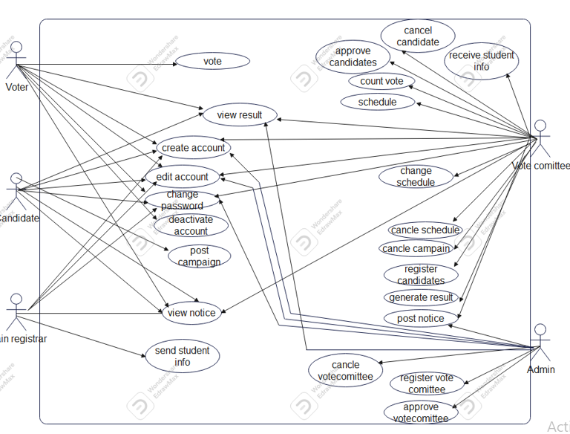

*Figure 1: use case diagram*

# 2.3.3 Business Rule

A business rule is effectively an operating principle or policy the software must satisfy. Our new system has the following business rules.

**BR1**: The Candidate should not be graduate student class.

**BR2**: The candidate should be free from any addiction and discipline case.

**BR3**: The Candidate should have CGPA greater than or equal to 3.0.

**BR4**: The voters can vote only one candidate.

**BR5**: the vote committee registers the candidates.

**BR6**: the voters should be students.

**BR7**: the administrator must select or register the vote committee.

**2.3.4 User Interface prototype**

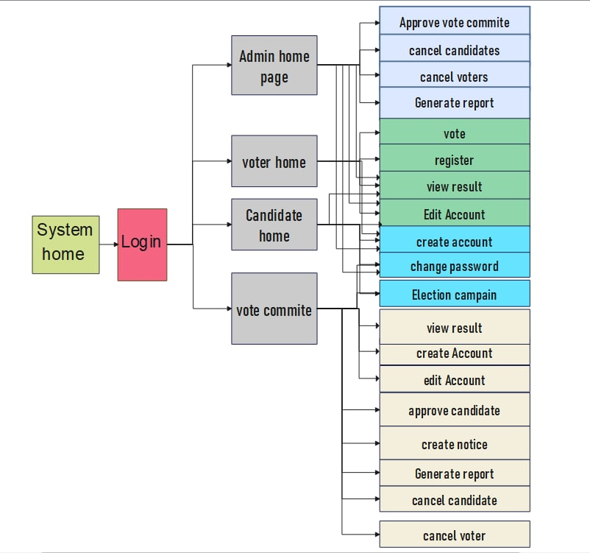

*Figure 2: user interface prototype*

**2.3.5 State chart diagram**

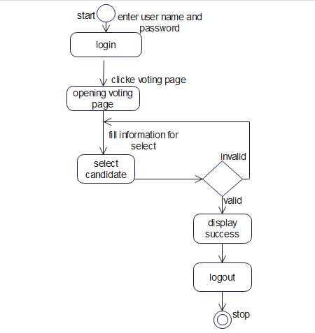

*Figure 3: state diagram for voting*

Not allowed

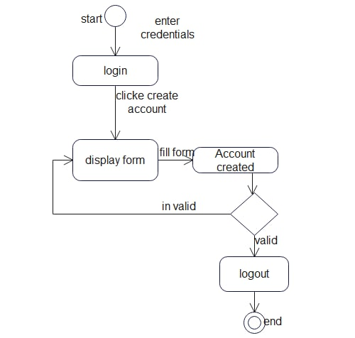

*Figure 4 : State chart for create account*

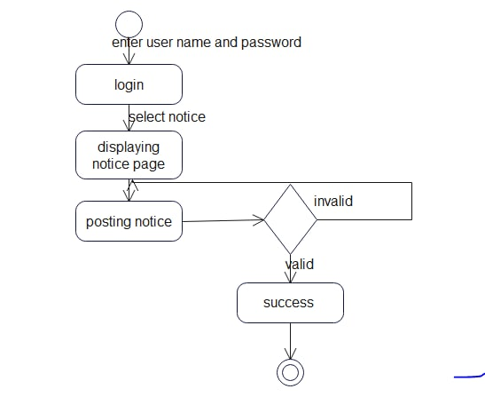

*Figure 5 : State chart for create notice*

# 2.3.6Activity Diagram

An activity diagram is a UML diagram that provides a view of the behavior of a system by describing the sequence of actions in a process. In UML, an activity diagram is used to display the sequence of activities. Activity diagrams show the workflow from a start point to the finish point detailing the many decision paths that exist in the progression of events contained in the activity.

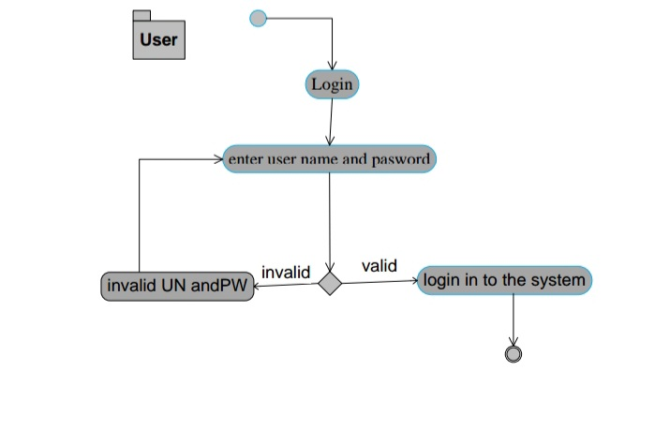

*Figure 6: activity diagram of login*

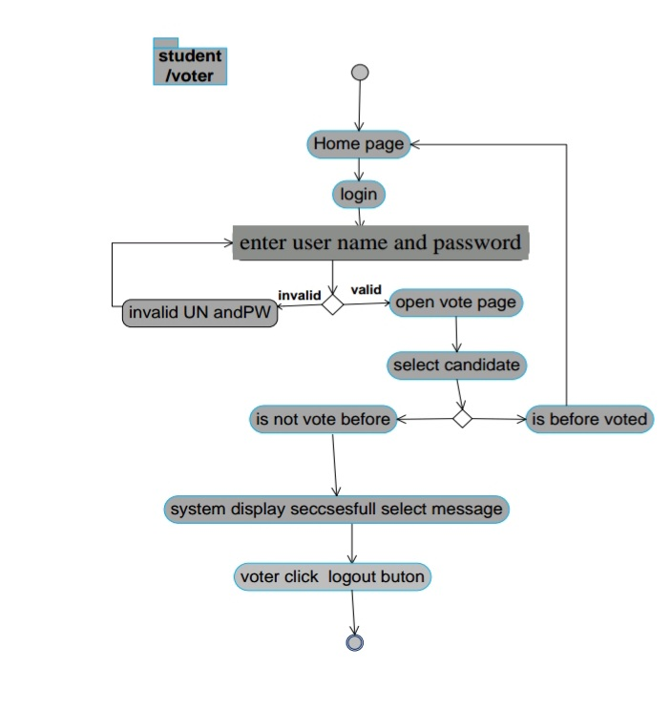

*Figure 7: Activity diagram of voting*

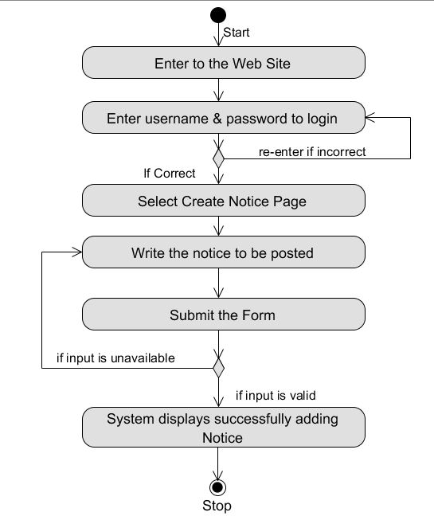

*Figure 8 : Activity Diagram for Creating Notice*

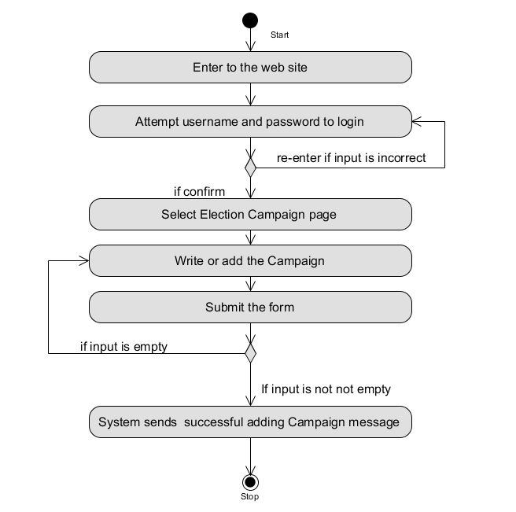

*Figure 9 : Activity Diagram for Election campaign*

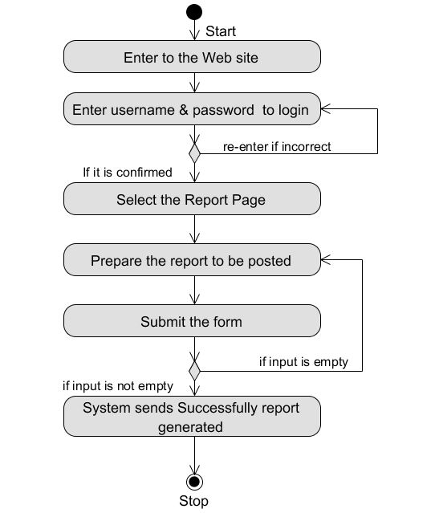

*Figure 11: Activity Diagram for Report Generation*

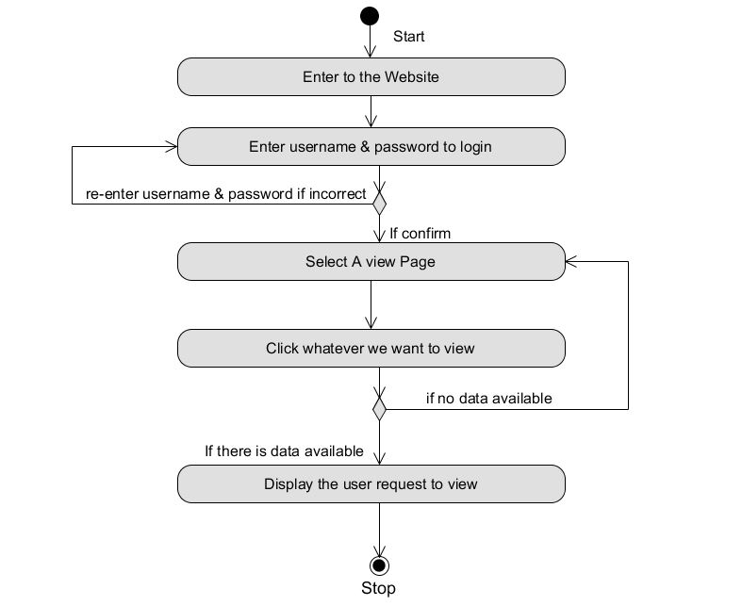

*Figure 12: Activity Diagram for View*

# 2.3.7. Sequence Diagram

The sequence diagram modeling is used to show the interaction between the object and actors in sequence way. It depicts the sequential flow of messages among objects and actors.

From our project the sequence diagram of a few ones are listed below:-

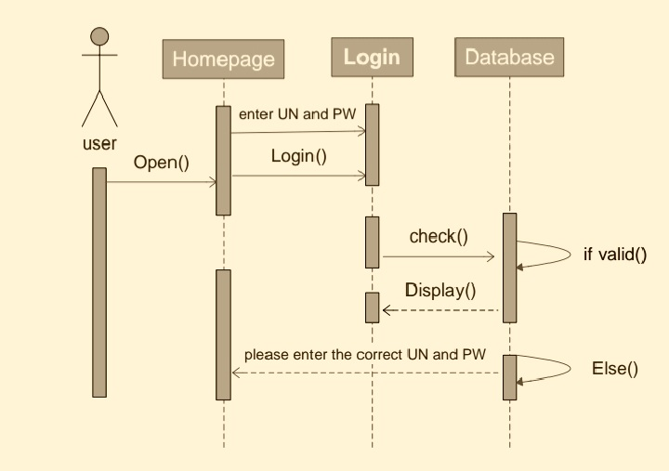

*Figure 13 : sequence diagram of login*

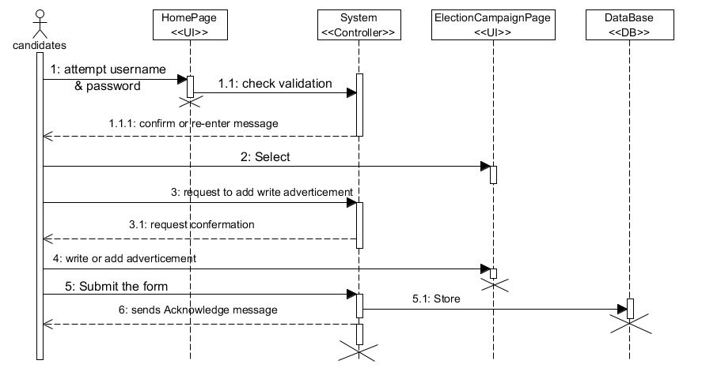

*Figure 14 : Sequence Diagram for Election campaign*

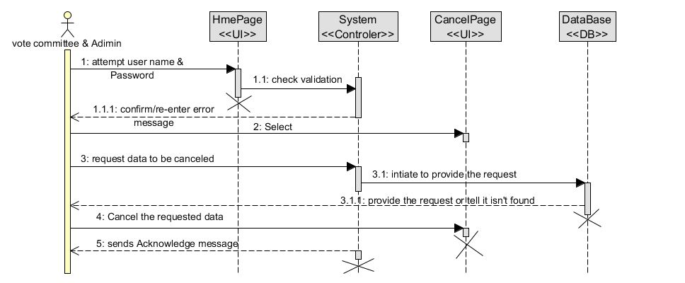

*Figure 15 : Sequence Diagram for Cancellation*

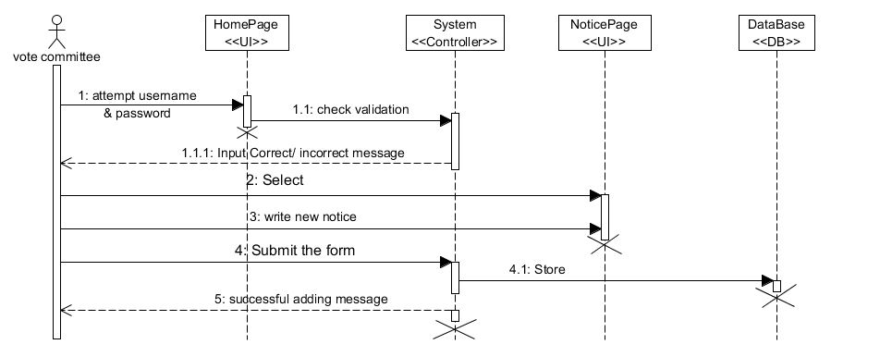

*Figure 16 : Sequence Diagram for Creating Notice*

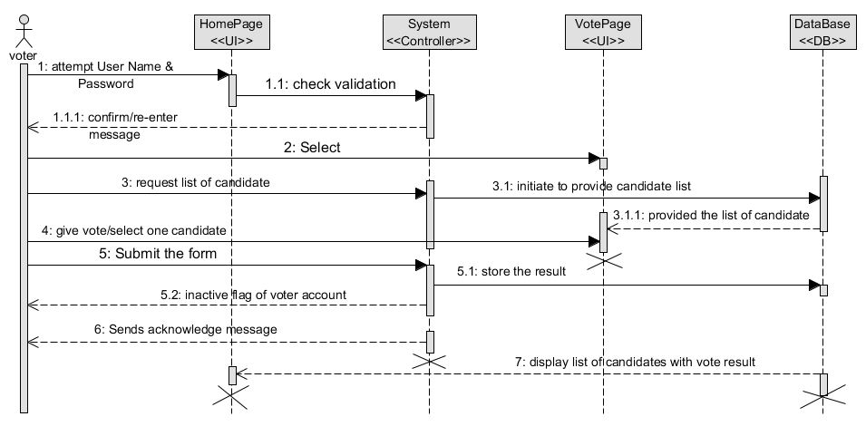

*Figure 17: Sequence Diagram for Voting*

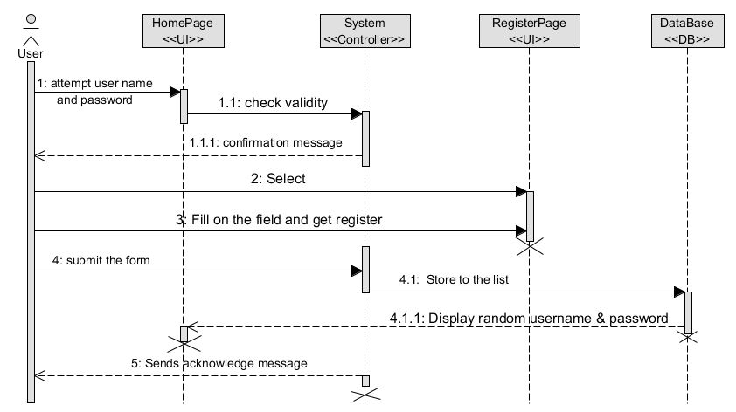

*Figure 18 : Sequence Diagram for Registration*

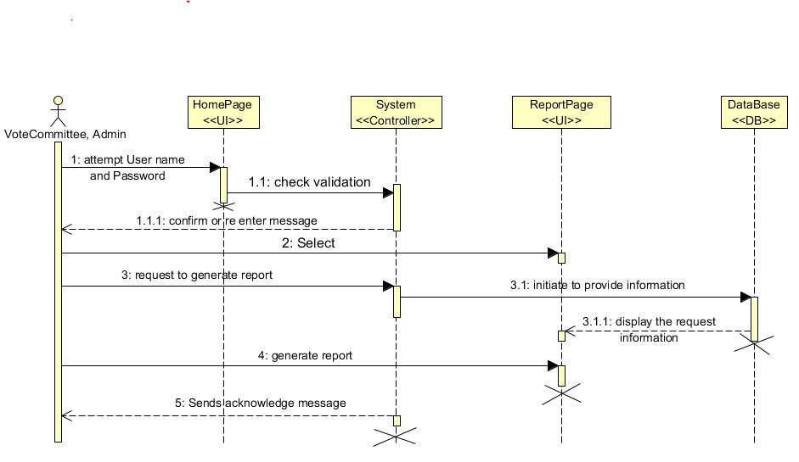

*Figure 19 : Sequence Diagram for Report generating*

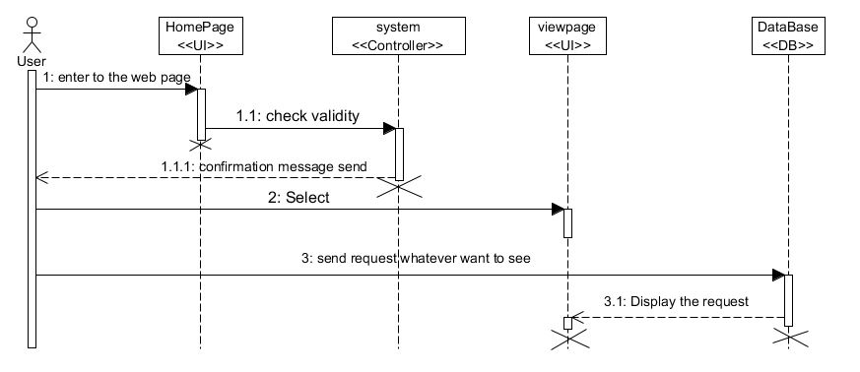

*Figure 20: Sequence Diagram for View*

**2.3.8 Analysis Class Model**

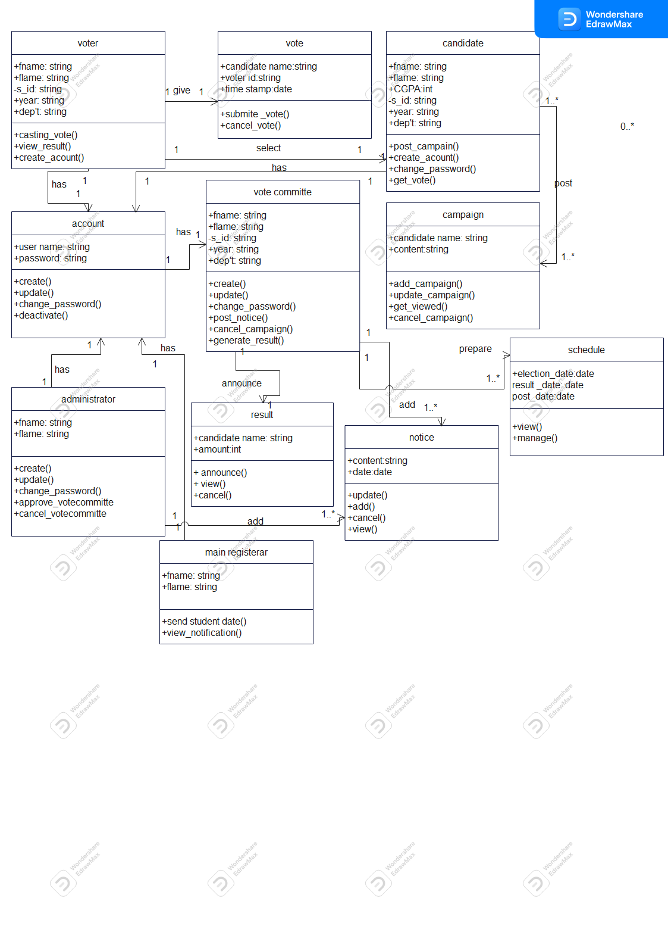

*Figure 21: Analysis class model*

# 2.3.9Logical Model

**Logical model for Login**

Display Login Form

Accept username and password from the user

If “Login” button is clicked {ss

Open database

Open account table

Check if username and password is matched

If username and password matched {

Display user’s home page}

Else {Display error message}

Close the database}

Else if “Cancel” button is clicked {

Clear all the inputs and refresh the form and display login form

End function

}

**Logical model for Register**

Login to system

Select page of registration

Display the registration page

Fill the form for registration

If submit and check {

The system displays stores the data

Display sends successfully message}

Else {

Display the form with error

Fill the form again

Click submit

}

**Logical model for Election Campaign**

**S**elect Election Campaign Page

Display the form

Fill the form

If “submit and correct” {

The system storesto database

The system sends successful message}

Else {

Display fill the form}

Display

**Logical model for creating notice**

Select notice page

Display the fill form

Fill the form

If “submit form and correct” {

The system stores the notice to database

The system sends success message}

Else {

The form displayed with error

}

The user log out from the system

**Logical model for Cancel vote**

Login

Select cancellation page

If “cancel existing member” {

Display the form

If “click submit” and valid “{

The system sends success message}

Else {

Display the form with error}

Else {

Another page}

**2.4 Non- Functional requirements**

Non-functional requirement is a specification that describes the system’s operation capabilities and constraints that enhance its functionality. These may be speed, security, reliability, etc.

* **User Interface**

The system’s interface should be easy to use and be easily understood by any new user who might not have any clue before about the system. The user will only need basic computer skills to understand how the system works because the prosed system is much user friendly.

* **Performance**

The system should have an average response and access time. It announces all information that would be reaching for the clients /students, is as soon as it posted to the system.

* **Errorhandling**

This system allows preventing or eliminating of error by displaying the message box or the system warns the users who make errors.

* **Availability**

The system should be available for access at the time of election.

* **Reliability**

This describe that the voting system performs correctly for long time. Since the user of system is a large number of students, the system will be best in handling errors.

* **Security**

This allows only authenticated users are login in to the system and should be able to vote.

# 2.5 System requirements

Systems Requirement includes the requirements in developing this system in the process of software and human interaction.

**Process Requirement:** The process of our project accept inputs from the user, process that input according to the instruction, finally produces output and displays it. To do those activities use CPU (Central Processing Unit) capacity of the system for processing purpose, Hardware and Software devices, power for activating the system ,Client computer (desktop or laptop any type brand ) with full accessories, Network cable, Server computer and Web browser such as Mozilla Firefox, Google chrome, etc.

**Input Related Requirements:** The proposed system can take input from the authorized user and check the validation of the input. It also needs correct input to display correct output to end user.

**Output Related Requirements:** The proposed system can display the appropriate output after the system accepting inputs from the authorized user and process it according to the instruction.

**Storage Related Requirements:** The system can store any data inserted in to the system in appropriate manner. The stored data can be kept in database permanently and can be retrieving easily when the user accesses it.

# 2.5.1 Hardware requirements

The hardware tools that we will use in our project are listed below with their functionality.

*Table 15: hardware tools*

|  |  |  |
| --- | --- | --- |
| **No** | **Name** | **Function of hardware** |
| 1 | Personal computer(pc) | Almost all tasks of our project are performed on computer. |
| 2 | Flash disk | Required for data movement to store & transfer data from one PC to another PC. |
| 3 | Paper and pen | For writing all necessary documentations associated with the project. |

# 2.5.2 Software requirements

Software’s that we used in our project are:-

*Table 16 : Software Tool*

|  |  |  |
| --- | --- | --- |
| **No** | **Name** | **Function of Software tools** |
| 1 | Window10 operating system | It is used for the system since it is readily available in laboratories. |
| 2 | MS word 2010 | For documenting the corresponding deliverables associated with the project. |
| 3 | Notepad++ | Working area used for writing the code. |
| 4 | Lucid Chart, DB schema and Edraw Max | Software tool that used for drawing UML diagrams. |
| 5 | PHP | Language used for doing project. |
| 6 | MySQL | Software used for creating the project database. |
| 7 | Xampp Server | Create a local web server. |

# 2.6 Key abstraction with CRC Analysis

Domain Modeling (Class Responsibility Collaboration /CRC/)

Class responsibility collaboration is a collection of standard index cards that have been divided into three sections. A class represents a collection of similar objects, a responsibility is something that a class knows or does, and a collaborator is another class that a class interacts with to fulfill its responsibilities. Some CRC analysis of our project is:-

*Table 17 : CRC diagram for Candidate*

|  |  |
| --- | --- |
| Candidate | |
| Create Account  Get vote  Post campaign  Register | Notice  Account  Voter  Vote committee |

*Table 18 : CRC diagram for Voter*

|  |  |
| --- | --- |
| Voter | |
| Register  Create Account  View result  Give vote | Vote  Candidate  Account |

*Table 19: CRC diagram for Vote Committee*

|  |  |
| --- | --- |
| Vote Committee | |
| Create Account  Post Notice  Registered  Control vote | Notice  Account  Candidate  Vote |

*Table 20 : CRC diagram for campaign*

|  |  |
| --- | --- |
| Campaign | |
| Give information to about candidate  Adding campaign  Destroy campaign  Update campaign | Candidate  Voter |

*Table 21 : CRC diagram for result*

|  |  |
| --- | --- |
| Result | |
| View result of vote  Adding result information | Administrator  Candidate  Voter  Vote committee |

**2.6.1 Identifying Change Case**

Change case will used to describe potential modifications requirements to the system.

There are many cases that change the content of the project. From these:-

* **Missing the users demand: -**if our system cannot component the customer’s idea the team asses the project again.
* **Missing activities: -**Where there the important activities missed in each project development phase and the developing team latterly understood them, they should include them.
* **Important comments: -** When crucial comments are raised from the advisor, teachers and examiners that should be included and excluded the developing team assess the project again.

# CHAPTER THREE

# 3. System Design

# 3.1 Architectural Design

The general architecture of the proposed system is three-tier architecture, which are the  
presentation layer, the business logic layer and the data access layer. The presentation layer usually contains the user interface components, resides on the client machine and the business logic and the data access layers will reside later on the server, and depicts the general architecture of our system.

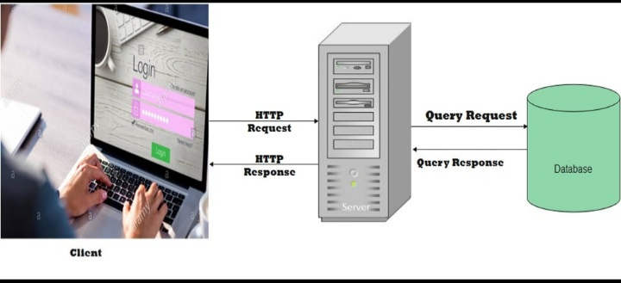

*Figure 22 : System Architecture*

# 3.1.1 Component Modeling

Component diagrams are different in terms of nature and behavior. Component diagrams are used to model physical aspects of a system. Physical aspects are the elements like executable, libraries, files, documents etc. that resides in a node. So component diagrams are used to visualize the organization and relationships among components in a system.

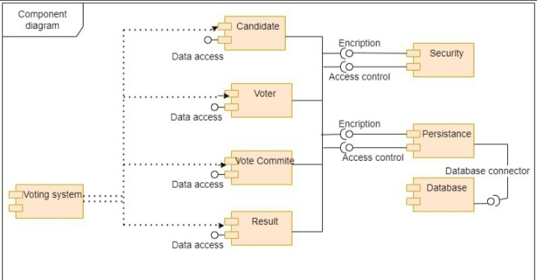

*Figure 23: Component modeling*

* + 1. **Deployment Modeling**

Deployment diagram is used to visualize the topology of the physical components of a system when the software components are deployed. The purpose of the deployment diagrams are used for describing the hardware component where the software components are deployed.

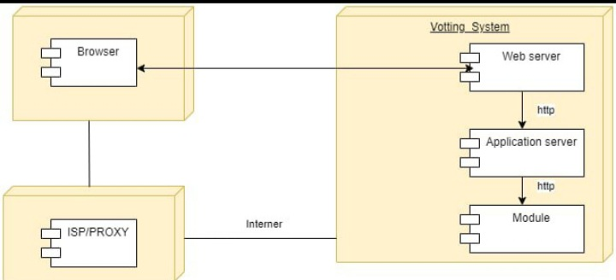

*Figure 24: Deployment modeling*

## 

## 3.2 Detail Design

## 3.2.1 Design Class Model



*Figure 25 : Detail class model*

# 3.2.2 Persistent Model

Persistent data management is basically used to represent the design of the database, usually a relational database. It deals with how the persistent data that is the files with database are stored and managed. The persistent classes are used to store most important and permanent information of the system.

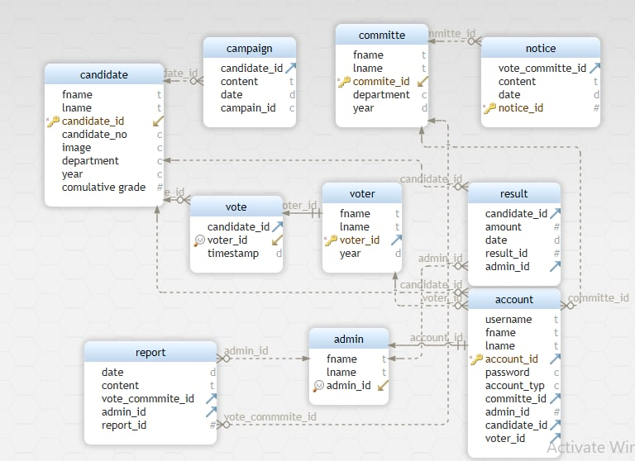

*Figure26 : Persistent mode*

# 

# 3.3 Access Control and Security

In this system, different actors have access to different functionality and data. Therefore, these privileges prevent unauthorized users from accessing data’s which they have not granted to access. In the access of the system, our system needs to be secured that different users have different privilege so that we give a specific permission for each user to access the system.

*Table 22: Access Control and Security*

|  |  |  |  |  |
| --- | --- | --- | --- | --- |
| Responsibility | Actors | | | |
|  | Administrator | Vote committee | Voter | Candidate |
| registration |  |  |  |  |
| Candidate registration |  |  |  |  |
| Change passwordand edit account |  |  |  |  |
| Give vote |  |  |  |  |
| Generate report |  |  |  |  |
| Cancel candidate |  |  |  |  |
| Cancel vote/ voters |  |  |  |  |
| create account |  |  |  |  |
| create notice |  |  |  |  |
| Post campaign |  |  |  |  |
| View result |  |  |  |  |
| Approve candidate |  |  |  |  |
| Approve vote committee |  |  |  |  |

# 3.4User Interface Prototyping

User interface prototype is to indicate the surface that can be used by user and the system.

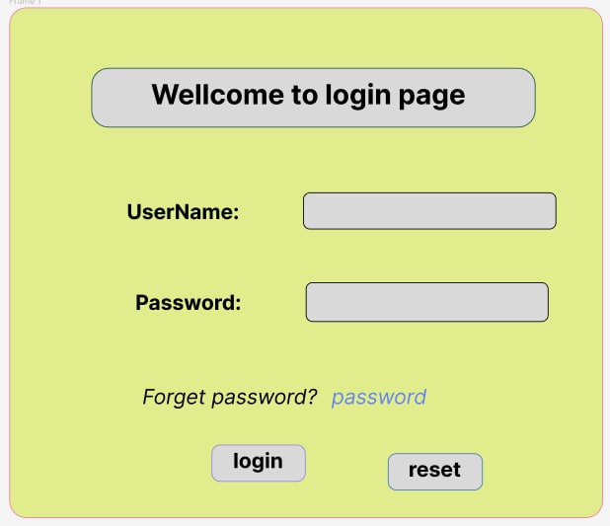

*Figure 27 : login page*

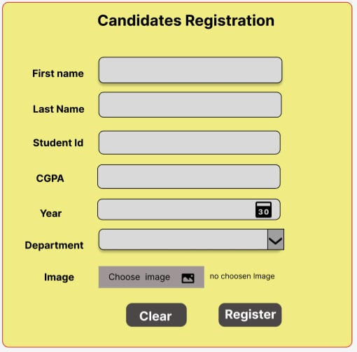

*Figure 28 : Candidates registration page*

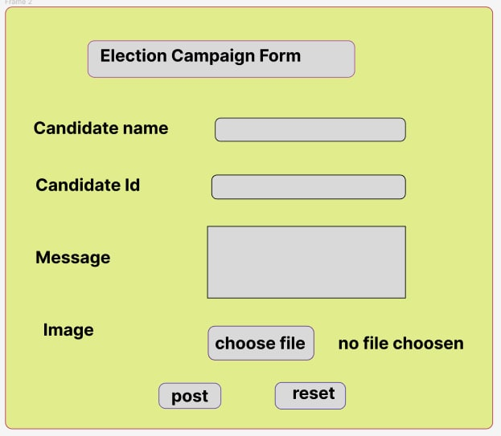

*Figure 29 : Election campaign form*

**References**

* + 1. Grady Booch, in Object-Oriented Analysis and Design
    2. A Roger S. Pressman Software Engineering, A practitioners’ Approach, Seventh Edition, New York, 2007.
    3. Karl Popper, in Objective Knowledge: An Evolutionary Approach
    4. Frank Herbert in Object-Oriented of Configuration management
    5. Distribute system and principles and 2nd Edition by Andrew TanenBaum & Maarten Van Steen
    6. Requirements engineering a good practice guide, Ramos Rowel and Kurts Alfeche, John Wiley and Sons, 1997
    7. Jacobson, M. Christerson, P. Jonsson, & G. Overgaard, Object-Oriented Software Engineering*—* a Use Case Driven Approach*.* Addison-Wesley, Reading, MA, 1992.
    8. J. Rumbaugh, M. Blaha, W. Premerlani, F. Eddy, & W. Lorensen, Object-Oriented Modeling and Design*.* Prentice Hall, Englewood Cliffs, NJ, 1991.
    9. R. Wirfs-Brock, B. Wilkerson, & Lauren Wiener, Designing Object-Oriented Software.Prentice Hall, Englewood Cliffs, NJ, 1990.
    10. G. Booch. ( 1994.). Object-Oriented Analysis and Design with Applications, 2nd ed.,. Redwood City, CA, : [Booch, 1994] .
    11. Jovanović, Irena “Software Testing Methods and Techniques”.
    12. <http://en.wikipedia.org/wiki/Systems_design>
    13. Functional requirement vs. nonfunctional requirement [www.google.com/](http://www.google.com/)
    14. UML diagram, https://www.tutorialspoint.com/uml/uml_class_diagram.htm

# Appendixes

As we describe in the methodology part, we use the method of interview, observation, and documentation to gather essential information. We had some conversation with Habte Mariam, one of the members of Students’ union in Poly Campus; and here are the questions we raised for him.

* What are the problems raised in the manual system?

_______________________________________________________

* Is the result of election trustable?

_______________________________________________________

* What kind of mechanism do you use to protect welfare of the election?

_______________________________________________________

* How the students elect their representative?

_______________________________________________________

* What is the mechanism you use to the announcement of new candidate to the students?

_______________________________________________________

* Is there any technique for controlling ones voting cannot vote more than once?

_______________________________________________________

* What do you do for participate the whole students in the vote time?

_______________________________________________________